Steven Lichtenberg, NRP, CHSOS-A, CHSE 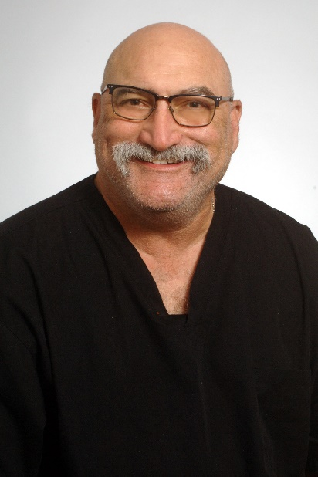
Steve has been a working Paramedic for 13 years. He has been doing simulation professionally for 10 years. He started with moulage 15 years ago and expanded to simulation operations after a full career in software development. Steve is an AHA instructor teaching BLS, ACLS and PALS for 20 years as well as NAEMT classes including AMLS and TCCC. Combining both technology and medicine put him in simulation. He regularly presents at simulation conferences and does moulage workshops whenever time and circumstance allow. He loves to make silicone prosthetics for simulation and has recently started doing poured acrylic paintings. In addition, he is currently pursuing a master’s in health professions education degree with graduation expected in May 2025. When not playing at work, he enjoys his Jeep and Harley Davidson as well as exploring caves throughout the east and brewing beer at home.

